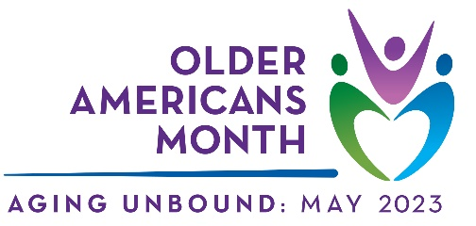
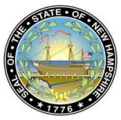
NH State Commission on Aging

2023 OLDER ADULT VOLUNTEER AWARD NOMINATION FORM

Anyone may nominate an individual or couple over the age of 60 who has made a significant contribution to their community as a volunteer. Any type of volunteer work qualifies from direct service, to advocacy, to leadership roles and more.

- The nominee must be someone whose volunteer work is in New Hampshire.
- Content of the nomination form will be used in the award announcement, press releases in relation to the award, and at the awards ceremony. The NH State Commission on Aging may use the content for other purposes celebrating the contributions of older adults to New Hampshire communities.
- Please complete the table below and use the second page (and a 3rd only if needed) to provide a detailed narrative summary describing the individual and their volunteer service or advocacy provided during the past year. Some or all of the following information is good to share in the summary: the type of service provided, the community need that was met, the number of service hours provided, innovative activities undertaken, how the volunteer’s efforts contributed to personal growth and the growth of others, the impact of the volunteer’s service or advocacy on the community, how the volunteer’s commitment and dedication stand out, and how the volunteer has inspired others to volunteer.

Please return by FRIDAY, MARCH 3rd! Thank you!

County:

Nominee(s):

Nominee(s) Address:

Nominee(s) Telephone #: | Nominee(s) Email:
Submitted by:

Your Telephone #: | Your Email:

Narrative Summary Describing the individual (or couple) and their volunteer service or advocacy provided during the past year:

